# How Much Does it Cost to Outsource Social Media Marketing

In today's digital age, social media has become a crucial part of any business's marketing strategy. Social media platforms like Facebook, Twitter, Instagram, and LinkedIn allow businesses to connect with their customers, promote their products or services, and build their brands online.

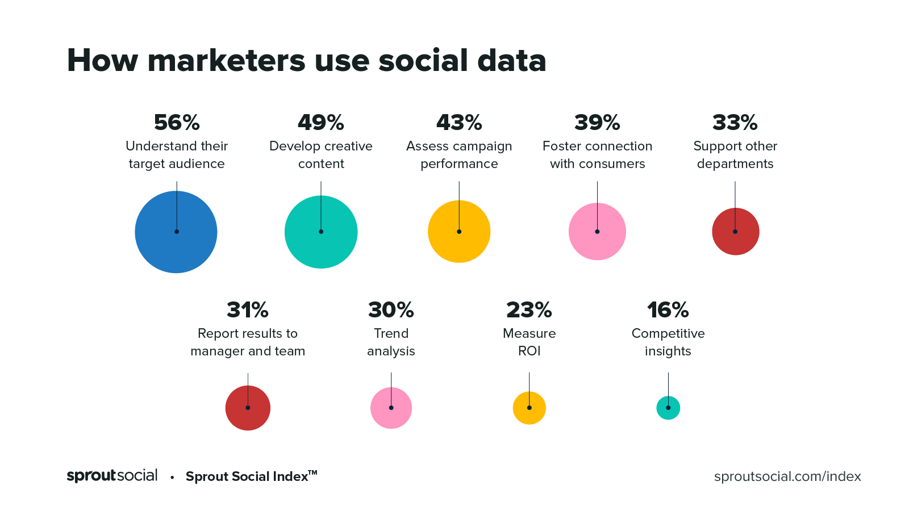

[Source](https://media.sproutsocial.com/uploads/2020/08/How-marketers-use-data_Index.png)

However, managing social media accounts and creating engaging content can be time-consuming and challenging for businesses, that's why many companies are turning to outsource social media marketing to experienced professionals.

But first, we need to know what is social media marketing, and how much does it cost to outsource social media marketing?

## What is Social Media Marketing?

Social media marketing mainly uses social media platforms to promote a product, service, or brand. It involves creating and sharing content on social media networks like Facebook, Twitter, Instagram, LinkedIn, TikTok, and YouTube to engage with a target audience, increase brand awareness, drive traffic, and ultimately, achieve business goals.

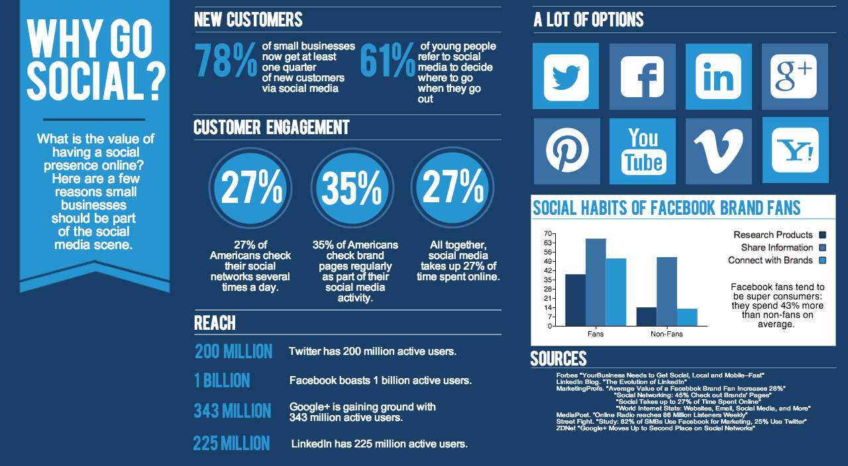

[Source](https://www.webhopers.com/wp-content/uploads/2016/05/Social-Media-Marketing-Benefits.png)

The goal of social media marketing is to build a strong online presence and engage with potential and current customers in a way that promotes brand loyalty and drives sales. It has become an essential aspect of modern marketing, with many businesses dedicating significant resources to social media marketing strategies.

## Why Should You Outsource Social Media Marketing?

If you're a business owner, it is very much likely that you know how important it is to stay competitive in today's market.

There are lots of benefits when outsourcing social media marketing and here are some of the most common of them:

### Time Savings

Managing social media accounts can be time-consuming, especially for businesses that are focused on other aspects of their operations. By outsourcing social media marketing, you won't have to spend hours working on your social media management cost and strategies. Not to mention onboarding an in-house social media management team can be just as time-consuming.

### Access to Expertise

Social media marketing agencies or even freelance social media managers are the best places that specialize in creating and executing effective social media strategies and ad campaigns. They have experience with different social media platforms and techniques like marketing campaigns or social media content write-ups that can help businesses navigate the constant-changing landscape of social media trends and algorithms.

### Reduced Errors

Since as mentioned above that these people are the best people to hire, because they have experienced social media manager(s), and social media marketer(s) which results in reduced errors of work and also, customers no longer have to worry about paying extra attention when their brand is being handled.

Third-party social media agencies with proven track records of success are most likely to have reduced errors in their work.

### Scalability

Less time and money spent means more potential to scale up your digital marketing toward a bigger goal. Social media agencies can scale their services based on a company's needs.

For example, they can provide additional support during busy seasons or help launch a new product or service.

### Increased Reach and Engagement

Social media marketing agencies can help a business achieve their social media reach and engagements as they can develop and execute campaigns that are tailor-fitted to a company's audience, which results in exposed brand awareness, sales, and even customer loyalty

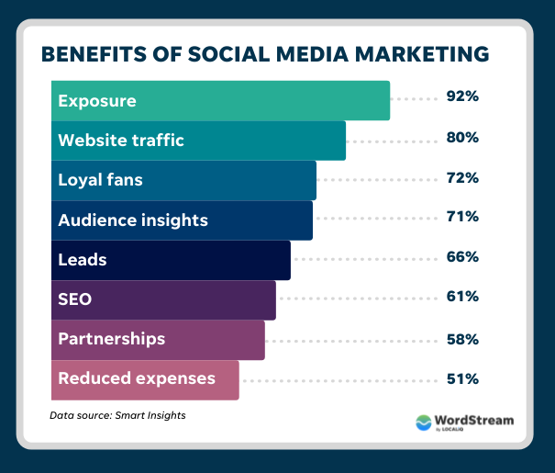

[Source](https://www.wordstream.com/wp-content/uploads/2022/02/benefits-of-social-media-marketing.png)

### Cost-effective

Outsourcing social media management can be more cost-effective than hiring an in-house social media team. Businesses can save money on salaries, benefits, and training costs by working with an agency.

## Factors Affecting the Cost of Outsourcing Social Media Marketing Services

There are many factors affecting the cost of outsourcing social media services and are as follows:

### Size of the Company

Company size has a big impact on social media marketing costs. More social media channels that need to be covered means more social media campaign to be able to reach potential customers, thus resulting in higher social media advertising costs.

### Level of Service Needed

Social media marketing services vary on different levels depending on how much promotion is needed, a few options may be in form of profile optimization, social media posts (like Facebook Page Ads, Promoted Tweets, Community Management, etc.), engagements, and advertising campaigns.

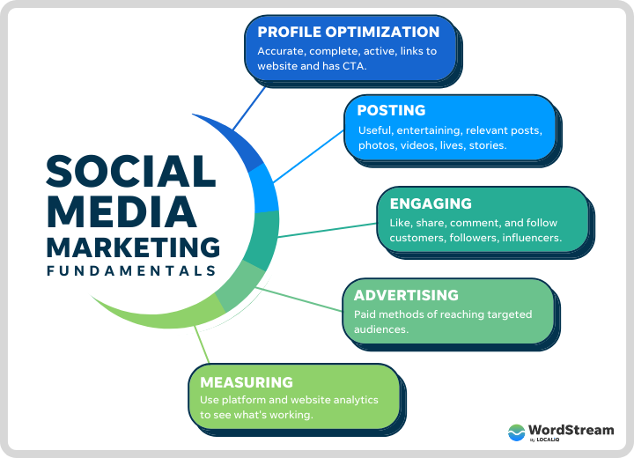

[Source](https://www.wordstream.com/wp-content/uploads/2022/02/social-media-marketing-fundamentals-wordstream.png)

### Location

The cost of outsourcing social media marketing may vary based on the location of the service provider. For instance, rates may be higher in areas with a high cost of living or where the demand for social media marketing services is high.

### Scope of Work

The more extensive and complex the scope of work, the higher the cost is likely to be. For instance, if you are looking for a comprehensive social media strategy that includes content creation, publishing, social media ads, and analytics, you can expect to pay more than if you only need someone to manage your social media accounts.

### Platform and Audience Size

The number of social media platforms and the size of the audience you want to target will also affect the cost of outsourcing. For instance, managing a large following on multiple platforms requires more time, effort, and resources than managing a small following on one platform.

### Third-Party Expertise and Experience

The more experienced and knowledgeable the social media marketing agency or freelancer, the higher the cost may be. Professionals with a proven track record of success and specialized skills, such as in social media advertising, may command higher rates.

### Contract length

The length of the contract can also impact the cost of outsourcing. A longer contract may provide a lower rate than a shorter one as the service provider can spread their costs over a longer period.

To avail of longer contracts, social media marketing agencies may create some package that suits your needs at lower or even discounted prices.

You may need to coordinate this with these agencies and your team to look over the contract before signing as it may have additional charges when you do early cancellations and or a more flexible contract duration.

## Social Media Marketing Cost

Social media costs can vary depending on many factors. However, most businesses spend about $2500 to $12,000 per month on social media marketing and advertising. Below is the breakdown by business size for your reference:

### For Small Businesses

Small or start-up businesses sometimes only require one social media manager which costs around $300 to $500 monthly, excluding all the marketing tools that need monthly subscriptions.

### For Medium sized Businesses

For mid-sized businesses that need to reach more audiences, they may need most likely 5-8 people who specialize in social media marketing services which cost around $2500 to $4000 monthly, excluding all the marketing tools that need monthly subscriptions.

### For Large Corporations

Large corporations may require a social media company to manage their social media presence which costs $5000 + and beyond $12,500 for social media advertising services. Sometimes, social media marketers who cater to large corporations include even monthly subscriptions on their monthly billings.

## Outsourcing Social Media Marketing vs. In-House Social Media Marketing - Direct Comparison

Some companies, especially those who are in start-up businesses, don't have any idea whether they should choose to outsource the social media team or just do some organic in-house hiring, so it's better to compare the two of them.

Here's a breakdown of some amounts you'll be encountering:

### Initial Setup Costs

Companies who wish to have good social media management may require some subscription or registration costs for outsourcing and this amount depends on which third-party social media agency you choose to subscribe to.

The breakdown of social media marketing includes:

* **Setting up social media account/s:**Most social media platforms are free to use, including setting them up for page verification, although some social platforms such as Facebook and Instagram (according to [NPR](https://www.npr.org/2023/02/20/1158401825/verification-on-facebook-and-instagram-will-now-cost-around-12-per-month)) may start to charge $12 a month.
* **Social media marketing tools:**Depending on the size and complexity of the business, social media management tools such as Hoot suite, Buffer, or Sprout Social may be necessary to manage multiple social media accounts efficiently. These tools typically charge a monthly fee, which can range from a few dollars to several hundred dollars.
* **Content Creation and Social Media Advertising Cost:**Creating high-quality content such as graphics, videos, social media ad campaigns, other social media packages, paid advertising or blog posts may require hiring a content creator or social media manager. The costs can vary between [$3,000 to $10,000](https://www.linkedin.com/pulse/how-much-does-content-creation-cost-sharlyn-carrington-mcm-she-her-/) a month.  
  Aside from the things mentioned above, training and resource-gathering are also costly and may vary from time to time.

### Ongoing Expenses

These expenses are defined depending on the package you want to build. Mainly, the internal social media marketing services are as follows:

* Employee Pay: between $3,000 to $10,000 a month depending on the skills and experience of the in-house talent who was hired
* Social media marketing tools: costs around a hundred to several thousand monthly
* In-house talents may need to be trained from time to time because there are continuous innovations happening. Costs may vary depending on how many employees need to undergo training and the training type.

### Total Cost of Ownership

To be able to establish an in-house team, you may need to pay an overall cost of around $7,000 a year for the startup and ongoing costs of marketing tools subscription only. This doesn't include the salary of every employee--which is between $36,000 to $100,000 (depending on the skills set and experience) per year for **each staff** you hire, while for outsourced team costs around $60,000 to $150,000 a year including **all paid ads and manpower**.

## Choosing the Right Social Media Marketing Provider

Now that we've gathered all the costs to outsource social media marketing, how would you know which provider is the best fit for your brand?

Before proceeding, we highly encourage you to check out [The New Workforce](https://thenewworkforce.com/). They provide well-equipped talents that specialize in social media management services, online marketing, IT support, customer services, and many more!

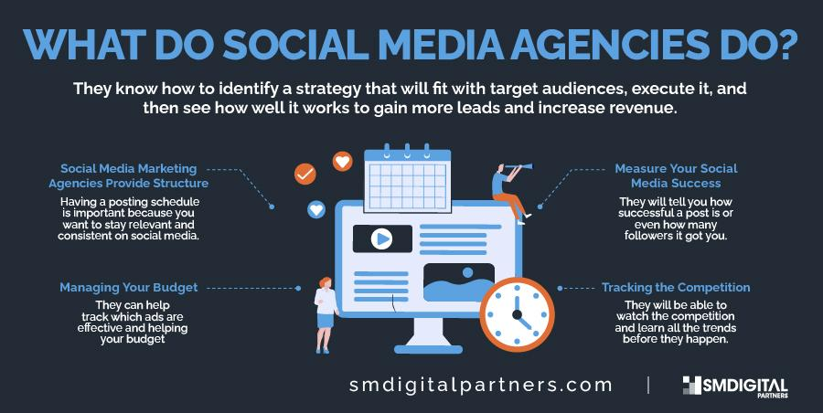

[Source](https://smdigitalpartners.com/wp-content/uploads/2022/05/WHAT-DO-SOCIAL-MEDIA-AGENCIES-DO-.jpg)

### Reputation and Experience

Look for a provider who has a proven track record of success in social media marketing. Take time and read their previous multiple clients' reviews as it speaks about their reputation. Doing this will filter out those that have bad reviews and will save you from so much trouble.

Check their portfolio, and case studies to evaluate their experience and expertise in your industry.

### Quality of Service

This is one of the vital indicators of choosing the right provider for your brand. Here's some checklist that you may need to look up:

* Are they certified by some institutions?
* Are they proficient enough when it comes to doing client onboarding?
* How many years are they in operation?
* Do they offer reputation management?

### Integration with Existing Systems and Social Media Management

They should be adaptive to the current trends of tools.

The social media landscape is constantly evolving, and your provider should be able to adapt to changes and update their strategies accordingly. Choose a provider who is flexible and agile in their approach.

### Customer Support

Does your provider have after-sales support? When someone from your team needs immediate assistance, are they available to connect? Do they handle complaints and concerns from other people?

### Strategy and Approach

Ensure that the provider has a clear strategy and approach that aligns with your business goals. They should have a well-defined process for creating and executing social media campaigns, tracking and measuring results, and making necessary adjustments.

### Communication and Collaboration

Communication is key to any successful marketing campaign. Choose a provider who is responsive and communicative, and who values your input and feedback. They should be willing to work collaboratively with you to achieve your goals.

### Transparency and Accountability

Look for a provider who is transparent about their methods, pricing, and reporting. They should be accountable for the results they deliver and be willing to provide regular progress reports and metrics.

### Value for Money

While cost is an important consideration, don't make it the only factor. Look for a provider who offers a good balance of quality and value for money. Remember, the cheapest option may not always be the best.

## In Conclusion

TL;DR: This article on social media marketing services covers a lot of checklists and also vital information that you need to tick to choose between outsourcing and in-hire. The benefits of managed social media are as follows:

* Time savings
* Reduced mistakes
* Saving money
* More brand engagements
* Expert support

The list of costs for both in-hire and outsourced social media marketing includes the:

* Hiring of employees
* Training
* Employee salaries
* Monthly subscription for tools

In the end, both in-house hire and outsourced social media marketing have advantages, and disadvantages, we can infer that outsourcing is much better especially when it comes to financing.

As you decide, make sure to gather your marketing budget, all the things that you need, and the current state of your business.